CA-231

assigement-2

19bca089

2020

**Q.1**

**Source:**

**<html>**

**<head>**

**<tit></tit>**

**</head>**

**<body>**

**<center> A complex table**

**<table border="1">**

**<thead bgcolor="yellow">**

**<tr>**

**<td colspan="3">invoice #123456</td>**

**<td colspan="2">14 january 2025</td>**

**</tr>**

**<tr>**

**<td colspan="2">pay to :**

**<br>**

**acme billing co.**

**<br>**

**123 main st**

**<br>**

**citivilaae na 12345**

**</td>**

**<td colspan="3">customre<br>john smith<br>231 willow way<br>southest northwestershire, ma 54321</td>**

**</tr>**

**</thead>**

**<tbody bgcolor="pink">**

**<tr>**

**<th>name/descriupition</th>**

**<th>oty.</th>**

**<th align="center">@</th>**

**<th align="center">cost </th>**

**</tr>**

**<tr>**

**<td align="center">paperclips</td>**

**<td>100</td>**

**<td align="center">0.1</td>**

**<td align="center">10</td>**

**</tr>**

**<tr>**

**<td align="center">staples(box)</td>**

**<td>100</td>**

**<td align="center">1.00</td>**

**<td align="center">100</td>**

**</tr>**

**</tbody>**

**<tfoot align="right" bgcolor="gray">**

**<tr>**

**<th colspan="3">subtotal</th>**

**<td> 110.00</td>**

**</tr>**

**<tr>**

**<th colspan="2"> tax</th>**

**<td >8%</td>**

**<td >8.80</td>**

**</tr>**

**<tr>**

**<th colspan="3">grand total</th>**

**<td>$ 118.80</td>**

**</tr>**

**</tfoot>**

**</table>**

**</center>**

**</body>**

**</html>**

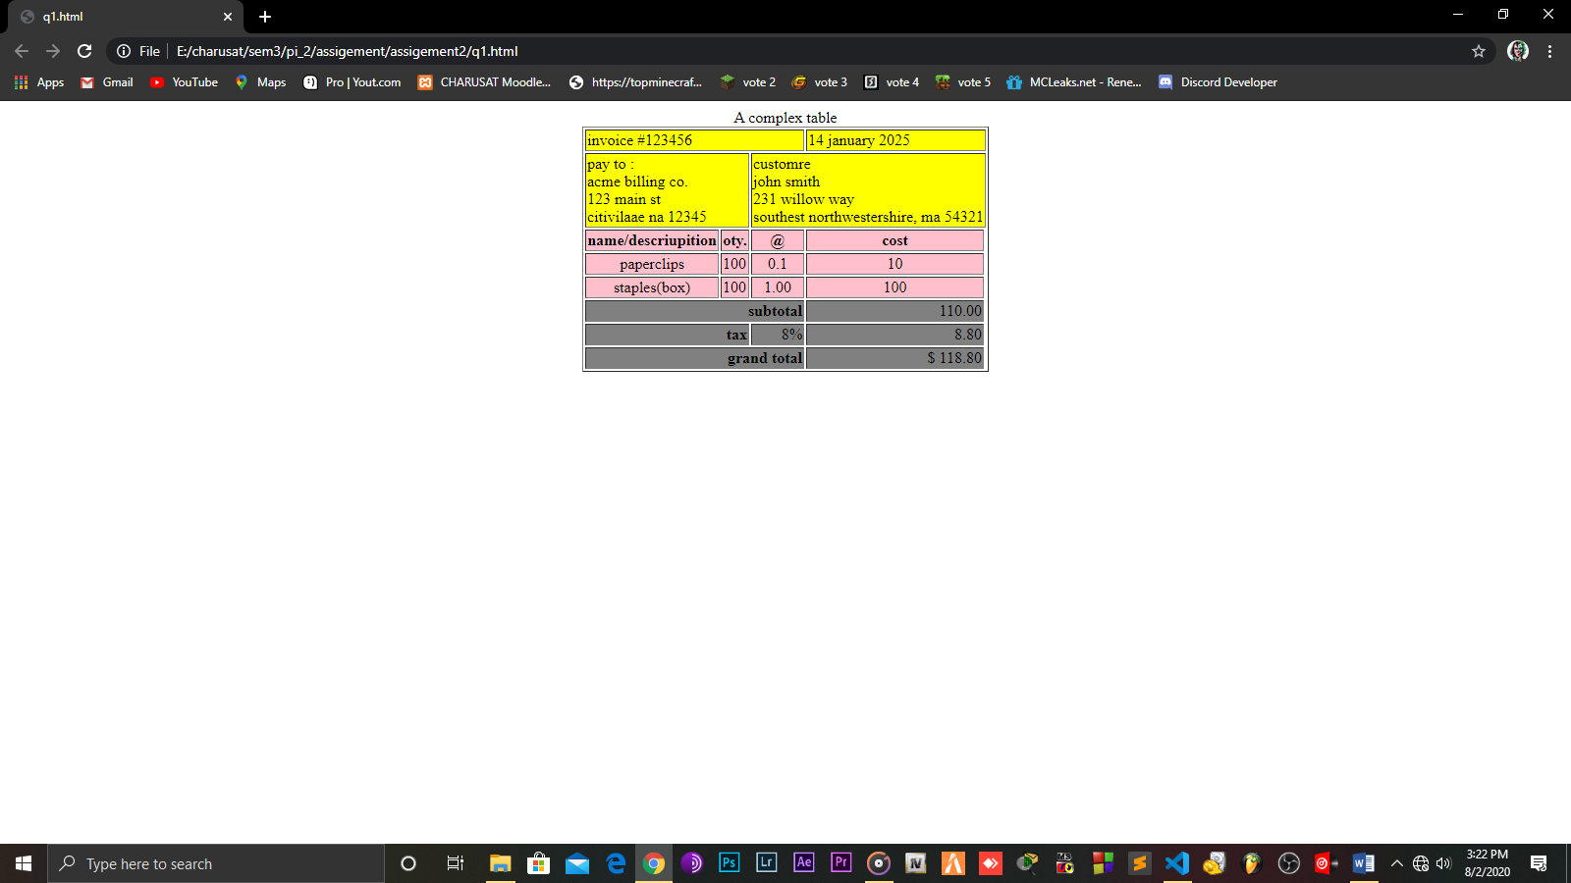**Output:**

**Q.2**

**Source:**

**<html>**

**<head>**

**<title></title>**

**</head>**

**<body>**

**<table border="1" align="center">**

**<tr>**

**<td colspan="3" align="center"><a href="#">exercise of list and tabl tag </a></td>**

**</tr>**

**<tr>**

**<td> <font color="red" align="center">list of item </font></td>**

**<td colspan="2" align="center"><font color="red">cmpica image </font></td>**

**</tr>**

**<tr>**

**<td rowspan="3">**

**<h3>list 1</h3>**

**<ul type="square">**

**<li>milk</li>**

**<li>toiet paper</li>**

**<li>cereal</li>**

**<li>bread</li>**

**</ul>**

**<h3>list 2</h3>**

**<ol>**

**<li>milk</li>**

**<li>toilet paper</li>**

**<li value="10"> cerel</li>**

**<li>bread</li>**

**</ol>**

**<h3>list 3</h3>**

**<ol reversed>**

**<li>milk</li>**

**<li>toilet paper</li>**

**<li> cerel</li>**

**<li>bread</li>**

**</ol>**

**</td>**

**<td>BCA</td>**

**<td align="center">MCA</td>**

**</tr>**

**<tr>**

**<td colspan="2"><center><img alt="this is cmpica image" width="50%" src="C:\Users\joker\Downloads\joker_logo.jpg" vspace="center"></center></td>**

**</tr>**

**<tr>**

**<td align="center">B.Sc(it)</td>**

**<td align="right">M.Sc(it)</td>**

**</tr>**

**</table>**

**</body>**

**</html>**

**Output:**

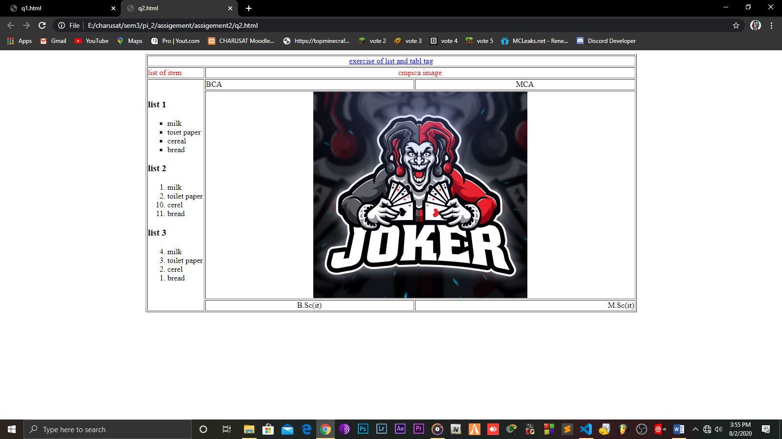

**Q.3**

**Source:**

**<html>**

**<head>**

**<title></title>**

**</head>**

**<body>**

**<table width="100%">**

**<tr>**

**<td><a href="#s1">section 1</a></td>**

**<td><a href="#s2">section 2</a></td>**

**<td><a href="#s3">section 3</a></td>**

**<td><a href="#s4">section 4</a></td>**

**<td><a href="#s5">section 5</a></td>**

**<td><a href="#s6">section 6</a></td>**

**<td><a href="#s7">section 7</a></td>**

**<td><a href="#s8">section 8</a></td>**

**<td><a href="#s9">section 9</a></td>**

**<td><a href="#10">section 10</a></td>**

**</tr>**

**</table>**

**<a name="s1"></a><h1>section 1</h1></a>**

**<br><br><br><br><br><br><br>**

**<br><br><br><br><br><br><br>**

**<br><br><br><br><br><br><br><br><br><br><br><br><br><br><br><br><br><br><br><br><br>**

**<a name="s2"><h1 >section 2</h1></a>**

**<br><br><br><br><br><br><br>**

**<br><br><br><br><br><br><br>**

**<br><br><br><br><br><br><br><br><br><br><br><br><br><br><br><br><br><br><br><br><br>**

**<a name="s3"><h1 >section 3</h1></a>**

**<br><br><br><br><br><br><br>**

**<br><br><br><br><br><br><br>**

**<br><br><br><br><br><br><br><br><br><br><br><br><br><br><br><br><br><br><br><br><br>**

**<a name="s4"><h1 >section 4</h1></a>**

**<br><br><br><br><br><br><br>**

**<br><br><br><br><br><br><br>**

**<br><br><br><br><br><br><br>**

**<br><br><br><br><br><br><br><br><br><br><br><br><br><br><br><br><br><br><br><br><br>**

**<a name="s5"><h1 >section 5</h1></a>**

**<br><br><br><br><br><br><br>**

**<br><br><br><br><br><br><br>**

**<br><br><br><br><br><br><br><br><br><br><br><br><br><br><br><br><br><br><br><br><br>**

**<a name="s6"><h1 >section 6</h1></a>**

**<br><br><br><br><br><br><br>**

**<br><br><br><br><br><br><br>**

**<br><br><br><br><br><br><br><br><br><br><br><br><br><br><br><br><br><br><br><br><br>**

**<a name="s7"></a><h1>section 7</h1></a>**

**<br><br><br><br><br><br><br>**

**<br><br><br><br><br><br><br>**

**<br><br><br><br><br><br><br><br><br><br><br><br><br><br><br><br><br><br><br><br><br>**

**<a name="s8"><h1 >section 8</h1></a>**

**<br><br><br><br><br><br><br>**

**<br><br><br><br><br><br><br>**

**<br><br><br><br><br><br><br><br><br><br><br><br><br><br><br><br><br><br><br><br><br>**

**<a name="s9"><h1 >section 9</h1></a>**

**<br><br><br><br><br><br><br>**

**<br><br><br><br><br><br><br>**

**<br><br><br><br><br><br><br><br><br><br><br><br><br><br><br><br><br><br><br><br><br>**

**<a name="s1o"><h1 >section 10</h1></a>**

**<br><br><br><br><br><br><br>**

**<br><br><br><br><br><br><br>**

**<br><br><br><br><br><br><br><br><br><br><br><br><br><br><br><br><br><br><br><br><br>**

**</body>**

**</html>**

**Output:**

